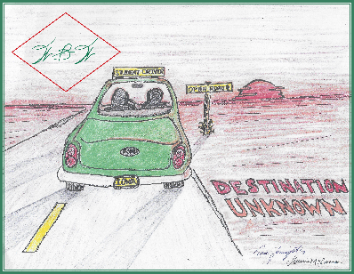
Lifelong Learners Hall of Fame
Nomination Form
Nominations must be completed using this form. Nominations may be completed electronically or be handwritten (but must be legible). To be considered, applications must be sent through email or postmarked by September 19th and all four sections must be accurately completed. If you have trouble with the form or prefer a paper copy, send an e-mail to parkitiowa@gmail.com to request assistance.
Nominee
Name:

Nominator

Name:
Mailing Address:
E-mail:
Telephone:
Are you an Iowa legislator? Please circle Yes No

Contribution to Lifelong Learning
Include
--what enduring contribution the nominee made to lifelong learning
--what lasting example did the nominee set and how
--how did the contribution improve quality of life for the community, state, or nation

Brief Bio

CHECKLIST:

___Contributions/Impact to lifelong learning explained in the correct space.
___Explanation of impact on lifelong learners is descriptive, concise, and clear
___Nominee’s bio in space provided for bio
___ Legible if handwritten
___Attachments are paper only and clearly labeled

Return completed form to:
parkitiowa@gmail.com
or
Wallace and Beverly Winkie Foundation
P.O. Box 291
Belle Plaine, Iowa 52208

